# **NAME: CHIDRI BUNESH**

# Mob:9030556687 EmailID:chidribunesh411@gmail.com

**PROFILE SUMMARY**

**CORE STRENGTHS**

**Results Oriented**

**Initiative**

**Impact and Influence**

**Customer Service Understanding**

**Analytical & Conceptual Thinking**

**Decision making skills**

**Analytical & Problem Solving Skills**

**Self-Motivated**

**Honesty and Integrity**

**Motivating people**

**Public Relations**

**People Management**

* A challenging &pursuing Technocrat with relevant technical & leadership skills.
* Participated in various competitions and events organized at School, &National levels.
* Participated in paper presentation in SV College of Engineering and technology.
* Organized a kabbaddi team as Mandal level,Tandur
* A quick learner and go getter; demonstrated leadership skills in successful completion of the academic project works.
* An effective communicator & team leader with strong analytical, problem solving & organizational abilities**.**
* Demonstration on Matlab & Simulink at Aurora Research & Technological Institute, Warangal.
* Demonstration onImplementation of Power Electronics in Simulink at SV college,moinabad.

**ACADEMIC CREDENTIALS**

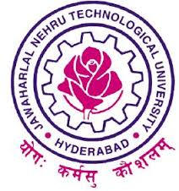

**JAWAHARLAL NEHRU TECHNOLOGICAL UNIVERSITY, HYDERABAD**

**72.0%**

Sri Venkateshwara College of Engineering and Technology (2011 - 2015)

**Bachelor of Technology – Electronics &communication Engineering**



**BOARD OF INTERMEDIATE EDUCATION, HYDERABAD**

**84.6%**

Narayana Junior College (2009 - 2011)

**Intermediate Education**

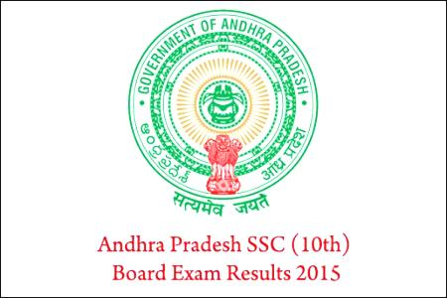

**BOARD OF SECONDARY EDUCATION,TANDUR**

**81.4%**

Gautami Model School (2008 – 2009) **Secondary School Certificate**

**Computer & Technical Skills**

C,& CORE JAVA

**Project Works**

**Mini Project @ College Campus**

**Title** : **ANDROID CONTROL HOME APPLIANCE**

**Duration** : one month

**Team size :** 3 members

**Role :** Team Lead

**Description:** The main objective of this project is to develop a home automation system with Android application controlled remote.. Even more it becomes more difficult for the elderly or physically handicapped people to do so. Remote controlled home automation system provides a simpler solution with Android application technology. Remote operation is achieved by any smart-phone/Tablet etc., with Android OS, upon a GUI (Graphical User Interface) based touch screen operation. Advances in mobile communications are paving way for many interesting applications using embedded systems. The mobile phone is one of the marvels of the last decade of the 20’h century.

**Major Project**

**Title : Voice Recognition Based Wireless Metal detection Robot**

**Duration :** Three months

**Team size :** 3 Members

**Role :** Team Leader

**Description**: Speech is the most important way of communication for people. Using the speech as interface for processes became more important with the improvements of artificial intelligent. We are interfacing Voice module to the Microcontroller and by assigning a prescribed voice command into the module for particular switching which are stored in the memory of Voice module. Motors are interfaced to the microcontroller through driver circuit. When the predefined voice commands are received to the voice module these sends the control signals to the microcontroller.

**PERSONAL DETAILS**

Father’s Name : Chidri Sudharshan

Date of Birth : 15/11/1993

Nationality : Indian

Marital Status : Unmarried

Passport No. : M8833555

Date of issue : 11/5/2015

Place of issue : Hyderabad

**EXTRA-CURRICULAR ACTIVITIES**

* Active participation in cultural events at school & college levels.
* Participated in dance competition.

**AWARDS**

* Merit certificate in kabbaddi.
* Certified in power point presentation